Quickest route from Red Deer to the Handhills Classic Ride and Pre-War Rally!
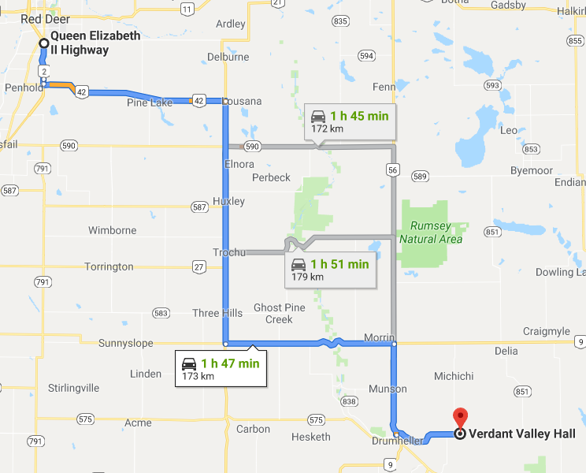
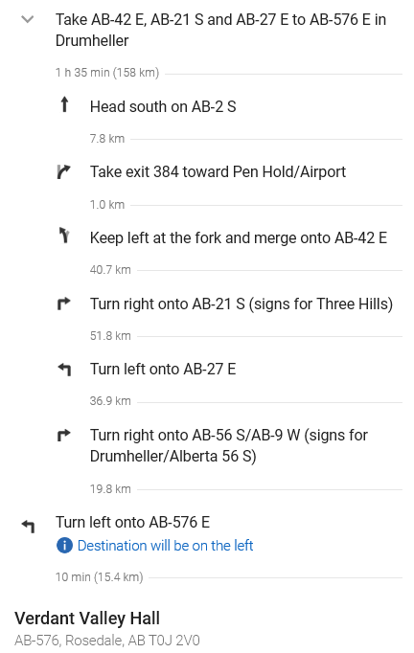
(GPS with this link: https://cutt.ly/YQFtoHCR .. Original link https://goo.gl/maps/AKSJSP17ChQZGHKU8)
